Soderling Lab Mouse Room Instructions
Location: GSRBII Protocol #: A288-11-11
Room: 1036
Rack: #1 back (STOCK), #2 front and back
Mouse Room Responsibilities and Division of Labor
Every member of the lab utilizing the mouse colony will be responsible for a weekday when they will:
- Check on their experimental mice
- Check for pups (cages labeled with pink “check pups” card)
- Check for plugs (cages labeled with green “check plugs” card
The lab tech(s) will manage stocks, set up all breedings, and toecut and wean all new litters.
In addition to checking on the colony once a week, each lab member is responsible for genotyping his/her experimental mice.
Checking Pups and Plugs:
Checking Pups
Pink Cards labeled “Check Pups” means you need to take the cage out of the rack and look for new pups. If pups are found you must record them in the “litters” section (red) of the Mouse Notebook. When counting, please try not to touch the pups (you may rub your scent onto them and cause the Dam not to take care of them or eat them). Also, if only one female is in the cage, turn the check pups sign upside down. It will keep the number of cages you check down to a minimum and the mouse room managers will turn it back once he/she weans the pups if there is still a mating pair in the cage. In addition to writing the information below, you must fill out a DLAR pink pups card (which can be found in the plastic container in the mouse room or right out side of the door in metal clipboard. This card has Date of Birth, Wean Date (19 days from Birth Date), # of pups. This card goes behind all cards on the cage.
Information to write in Lab Mouse Notebook: Cage number, sire (male), Dam (female), date of birth, # of pups (if any are dead put + the number in parentheses, for example 12 (+3) meaning 12 live pups and 3 dead pups). There is also a notes section. Notes may have information such as: if someone took the pups for an experiment, if the mom was moved to a different cage to avoid overcrowding, etc…
Checking Plugs
Green Cards labeled “Check plugs” means you need to check the female(s) in the cage for a plug. A “plug” is a white hard piece located in the mouse vagina after a male has had intercourse with her. We use this as a way to track embryos and pups. Females give birth 19-20 days after she plugs. It is helpful if you write the plug date on the card, we can track whether there is a re-plug event more easily. A re-plug is not very common but it does occur. Typically once a female is plugged she will not re-plug until after she gives birth. Some check plug signs will give further instructions such as “change to check pups after plug”. This is pretty self-explanatory, change the green “check plug” sign to a pink “Check Pups” sign. Another common instruction is to “MOVE TO HOLD” this means place the plugged female into a holding cage. These cages are marked HOLDING CAGE and contain ONLY females. See holding cage section for instructions on moving mice into holding cages. If you find a plug you must record it in the Mouse Notebook.
Information to write in Notebook: Cage number, sire (male), Dam (female), date plugged and notes. Notes may include comments such as: plug description, Dam gave birth the same day, Dam moved to holding, etc...
Breeding Mouse info Cards and Holding Cages
For mice that are used for breeding, it is important to keep track of them so that mice are not bred unnecessarily, mice that are sterile/too old are not used, etc. To accomplish this, each mouse used for breeding will have a card that lists mating dates, plug dates, and litter dates for easy reference (see card below). These cards are the white litter cards provided by DLAR where the pink litter cards are found. The blank side (back) is where we write specific mouse information.
Holding cages are used when a lab member wants to prevent mice from re-plugging or take a litter embryonically (ie, mice that are not set up for continual breeding). When you move a mouse that has plugged into a designated holding cage, you must cross it off on the cage information card and transfer the breeding info card with it. Record in the notebook “moved to hold” and list the new cage card number. See below:
Mating Mouse Info Card (back) Mating Mouse Info Card (front-Females Only)
_______ ________ ________
Litter Number | DOB | Number of pups

(Mouse ID)
1223
ArpC3^{f/f}
^{dob: 12/14/2013}

♀
Mating date:
Plug date:
(gender)
(Genotype)
(date of birth)

IMPORTANT: Remember to record plug in the notebook and write in notes section "MOVED TO HOLD"

GENERAL CAGES
General cages include stock and individuals cages. These should have mice of only one gender and not exceed 5 mice. Stock cage information cards are white and individual’s cage cards are the color assigned to the individual. These cards describe the number of animals in the cage, their genotype, toe number, and date of birth.
COLORED (for individuals) OR WHITE (stock animals) INDEX CARD EXAMPLE CAGE INFO CARD
♂
♂/♀
ArpC3^{f/f}:CaMKII-Cre
1056 | 12/1/2013 | ArpC3^{f/f}:Cre +
1058 | 12/1/2013 | ArpC3^{f/f}:Cre -
1059 | 12/1/2013 | ArpC3^{f/f}:Cre +
1063 | 12/1/2013 | ArpC3^{f/f}:Cre +

Strain
Animal ID | DOB | Genotype (if Needed)

Overcrowded Cages:
Occasionally you may find a green DLAR card that says OVERCROWDED. This is can be caused by several things: (1) there are more than 5 animals in a cage (2) pups are past weaning stage (3) more than one litter in a cage (4) more than 2 adults and a litter over 10 days old. If this occurs we have 2 days to fix the issue. Alert the lab techs and/or the person whose cage is overcrowded.

Order of Cards on cage: (Front to Back)
-"check pups" or "check plug" sign
*Cage Information Card (White for stock, colored for lab members)
-White Breeding/litter information Card
*Cage Card (white with cage number and barcode on it)
-Pups Card (PINK)
KEY * = Always on cage - = only when applicable

Toe Clips and Identification
Cut toes according to following diagram between P5-P10:
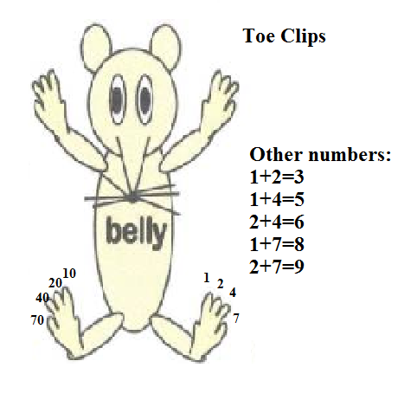
Use sheet in Mouse House to determine where to start your numbering system for a new litter.
For example, if you get a litter of 5 mice, and the sheet appears as shown:
Date Last toe clip Initials
11/10 115 ABC
11/11 122 DEF
You will toe clip your mice from 23-27, and record the date, “127” and your initials. Toe clips will only be used for the TENS and ONES digits of a mouse number. For example: A mouse given the number 236 will only have “36” clipped on their toes. However, it is VERY IMPORTANT that the ENTIRE MOUSE NUMBER is recorded into mLIMS and recorded on the mouse card.

