Peptide array

Solid-phase peptide synthesis (SPPS) [Robert Bruce Merrifield]
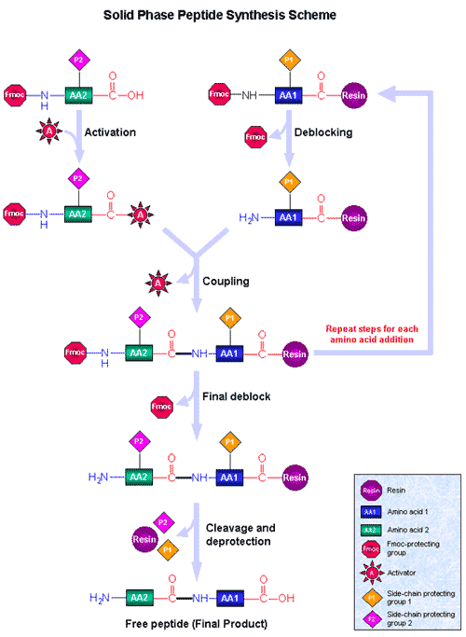

- Tubes (1.5mL screw cap tube, 0.5mL PCR tube[thin wall reaction tube with domed cap, autoclaved, Applied biosystems, N8010611], 10mL tube [SARSTEDT 13mL,101x16.5mm],
- Membrane
- Amino acid derivatives
- 20% Piperidine (200mL Piperidine/ 800mL DMF) [deprotection reagent for Fmoc-group]
- 2% Acetic Anhydride (20mL AA/ 980mL DMF) [capping reagent]
- NMP in 50mL Tube (wait for a while to settle down. Avoid light)
- HOBt•H2O 0.85g/5mL NMP (prepare every day)
- DIC 0.8mL/5mL NMP (prepare every day)
- Final deprotection 10mL TFA + 0.3mL Triisopropyl silane + 0.2mL water (mix well) never mix DMF and TFA!

- Array your peptide sequence (24x16(AtoP)=384 spots). Design the order so that you can cut the membrane in pieces.
- Peptide library design tool will be helpful ( GenScript; http://www.genscript.com/peptide_screening_tools.html)
- Input to Autospot analysis program (user; Admin, password; start)
- It will calculate the amount of AA you need (use excess estimate). Use 2 tubes if necessary.
- Is the reservoir solvent bottles filled? Check the washing DMF (use the Sigma). The amount will be calculated too, but use more (750mL to 900mL). Keep the reservoir beside the PC, wrap with foil to avoid light. Check that the tube is touching the bottom.
- Is the waste bottle emptied?
- Wipe the membrane stage with 70% EtOH.
- Connect the PC to Autospot. Use the red outlet. There is one SCSI to connect to the PC. Autospot has two plugs.
- Prewash the track. PC/Manual/Prime. Turn off by yourself after 20-30min.

Autospot Method

Check list before start SPOT synthesis
- Reservoir solvent bottles filled?
- Waste bottle emptied?
- All units switched on?
- Amino acid derivative stock solutions in place
- Mixing vial in place?
- HOBt and DIC stock solution in place?
- Dry membranes on the holder?
- Correct synthesis cycle selected?

- Run Synthesis / START
- about 2-2.5hrs, pause
- [capping] 15mL AA, 30sec
15mL AA, 3min
- [wash] 15mL DMF 1min x2
While doing washing, wipe the membrane stage with DMF
- [deprotection] 15mL PIP 7min x 2
- [wash] 15mL DMF, 2min x 9
- [wash] 15mL EtOH, 2min x 2
- Blot membranes between several layers of filter papers, then dry with air
You can pause here and store at 4C
- Final synthesis
- Final capping (AA)
- Final deprotection (PIP)
- Wash with EtOH
- Dry up (must be thoroughly dried)
- Use new cassette, new pipets, new diaper for TFA washing, also protect yourself
- [side chain deprotection]
- Immerse membrane for 1 hour in 10mL of TFA + solution.
- Wash membranes in 20mL DCM 4x
- Switch cassette back
- Wash membrane in 15mL DMF 2min x 4
- Stain the membrane with 1% bromophenol blue (100-200uL)
- Wash membrane in 15mL EtOH 2min x 2
- Dry up and store at -20C

Wash the robot with DMF for 20min, and wash without DMF for 20min

